2014/15 Season - A Mangers overview
Matt Bailey
Offerton Park FC completed the most successful season in our 5 seasons in Stockport District Sunday Football League by finishing 2nd in division 4.
This means Offerton Park FC will automatically win promotion to 3rd division.
In my opinion the 4th division is the hardest division to get out of due to the amount of new teams that have come out of other leagues and joined the league.
This season I have had the pleasure of working with some really good talented young players, that have shown a real desire for Offerton Park. They have shown fantastic commitment and at times played in tough games especially towards the end season, where the players have had pressure & intimidation. Our players have shown great application in all departments and I feel this was the making of the players.
With a couple of new additions to squad, I feel we can challenge again and hopefully go one better and win the league.
Have a great summer see you all in July.
Regards
Matt
Offerton Park FC (Open Age) 2014/15 presentation
Luke Levey - Players players & Top goalscorer (40 goals)
Danny Gardner - Most improved player .
Callum Burgen - Managers player.
Luke Levey - Trophy presentation of Players player trophy.
Gaz Jones - Managers Player
Chris Jones - Clubman of year
Phil Campbell - Special award for Rory Campbell
Offerton Park FC - Latest signing RORY THOMAS CAMPBELL.
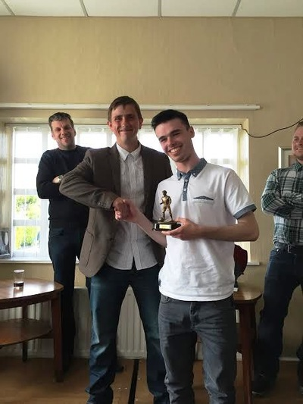
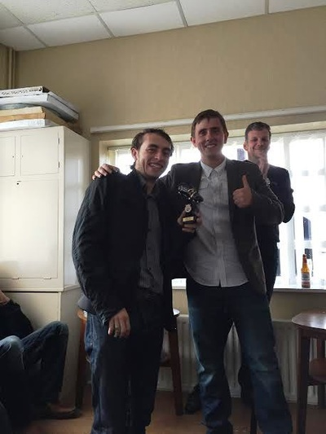
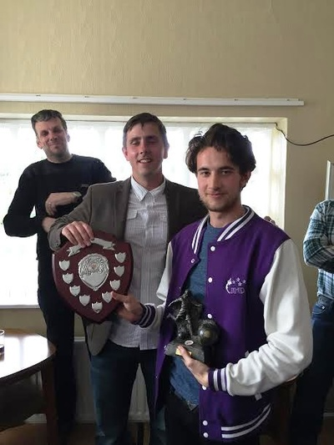
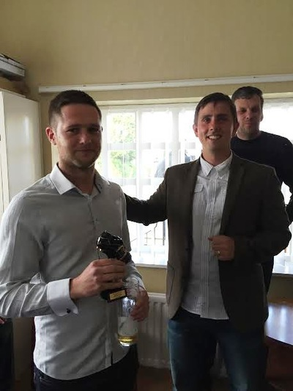
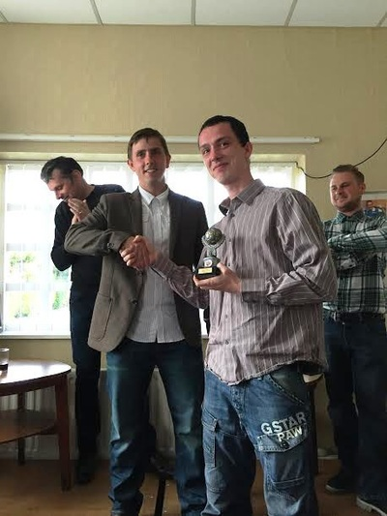
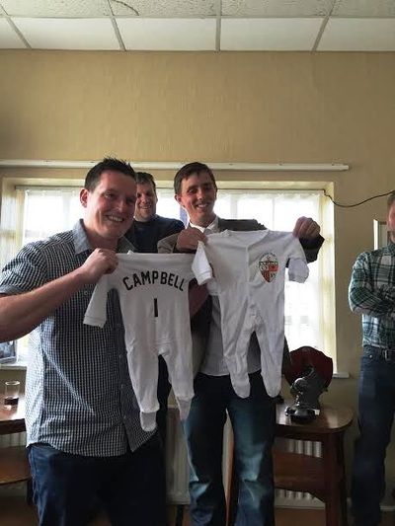
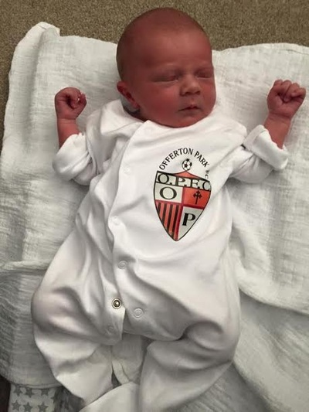
CREATE A FREE WEBSIT

